CIT608 INTRODUCTION TO DATA COMMUNICATION
NAMES:KATLEHO QHOBELA
STUDENT NUMBER:20250016
WEEK5 SELF STUDY

1. Scenario Analysis
In an Ethernet encoding scenario, data frames are prepared for transmission over a physical medium using Manchester encoding. The original binary data stream is transformed so each bit is represented by a transition in the signal, ensuring clock recovery and eliminating DC bias. For example, a logical ‘1’ is encoded as a low‑to‑high transition and a ‘0’ as a high‑to‑low transition in the middle of the bit period. This self‑clocking scheme simplifies synchronization between sender and receiver, reduces error rates, and adapts the signal to the Ethernet’s physical layer requirements for reliable 10 Mbps baseband transmission over twisted‑pair or coaxial cable in a local area network environment with typical noise conditions.

2. Concept Research
Quadrature Amplitude Modulation (QAM) is a digital modulation technique that conveys data by changing both the amplitude and phase of a carrier wave, combining two orthogonal carriers (I‑in‑phase and Q‑quadrature). QAM encodes multiple bits per symbol, increasing spectral efficiency. For instance, 16‑QAM maps 4 bits to one of 16 distinct amplitude‑phase combinations. Its role in communication systems is to boost data throughput while occupying the same bandwidth, making it essential for high‑speed modems, digital TV, and wireless standards where efficient use of spectrum is critical for performance.

3. Tool Practice
Simulating Phase Shift Keying (PSK) in Falstad shows how binary data modulates a carrier’s phase to represent symbols. In a basic BPSK setup, a ‘0’ shifts the carrier phase by 0°, while a ‘1’ shifts it by 180°. The simulation visualizes the modulated waveform and its constellation, demonstrating how PSK achieves robust transmission with simple phase detection at the receiver. The experience highlights PSK’s advantage of constant envelope, which reduces amplifier linearity requirements, making it useful for satellite and telemetry links.

4. Diagram Design
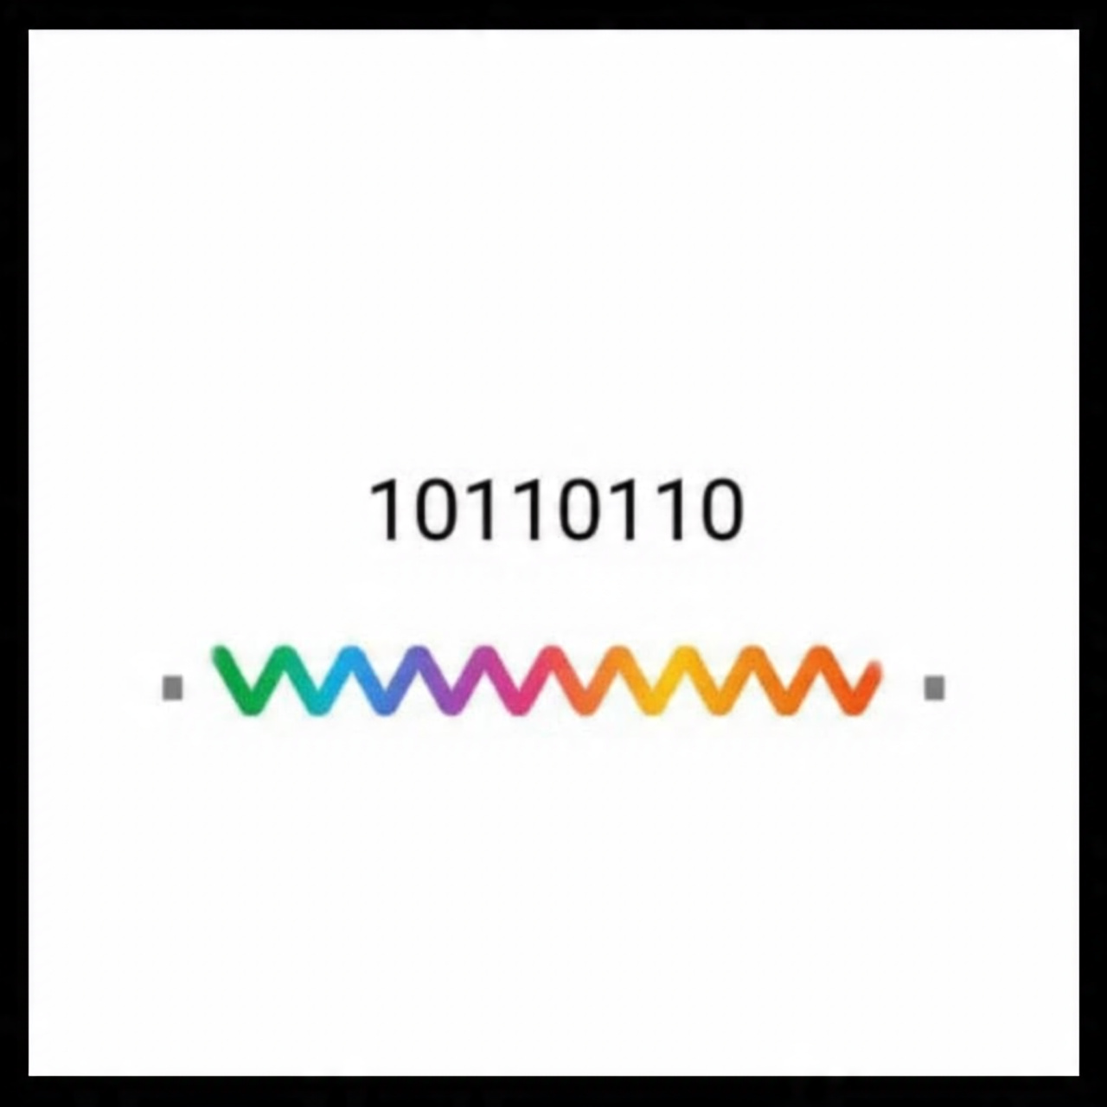
In Draw.io, an encoding waveform for Manchester encoding can be drawn as a time‑domain signal where each bit interval contains a transition: a rising edge represents a ‘1’ and a falling edge a ‘0’. The diagram should show the original binary sequence above the encoded waveform, illustrating the mid‑bit transitions. This visual explains how Manchester encoding embeds clock information into the data signal, enabling receivers to recover timing and data accurately, which is crucial for synchronous communication protocols like early Ethernet.

